Creating A New User In Eclipse
- Log into Eclipse (Must be signed in as an admin user).
- Navigate to the “Users Tab” and then click on “Users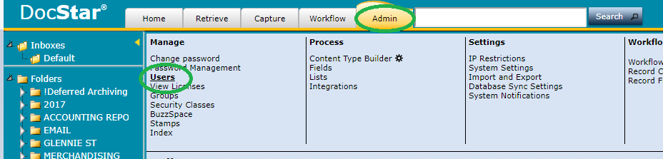
- Now we are ready to make our new user.
  - Username: This will be their user name. (This should be the users email address or in the format of it.
  - Enable Independent Password: This is how the user will log into eclipse. The password has to be at least 8 characters and at least 1 uppercase, 1 lowercase, 1 number and 1 symbol. This can be changed in the admin tab any time.
  - Enable Integrated: If active directory is set up on the network this can be used for the “single sign-on” feature. If this is the case then you can use the “LDAP Import” button to select from the AD list.
  - User Principal Name: You can use this to create a shortened name for the users to login with. Ex: NewUser@CompanyName.com could simply Login with NewUser if they use this section.
  - Admin Permissions: hover over each checkbox to get more information about what each grant the new user.
- Now that we have them all set up we need to add which groups they are part of.
  - In our example the user is currently part of the “Admin” and “View Only” groups. Too select them just hold control and select all the groups the new user should be part of.
