Setting up Datalink for Timberline using webservices

Eclipse Automation in Desktop Mode:
- Stop Eclipse Automation Service. Disable is it will run ongoing
- Run Debug.bat
  - Path C:\ProgramData\Microsoft\Windows\Start Menu\Programs\StartUp
Datalink Connection:
- DLL path:
  - C:\ProgramData\eclipse\DatalinkExecutables
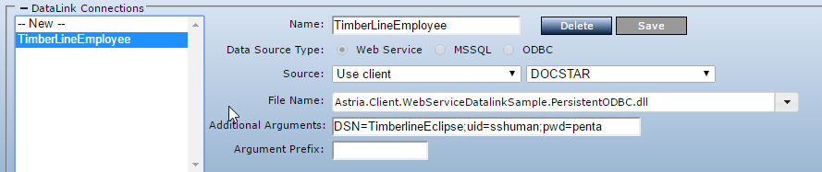

Datalinks:
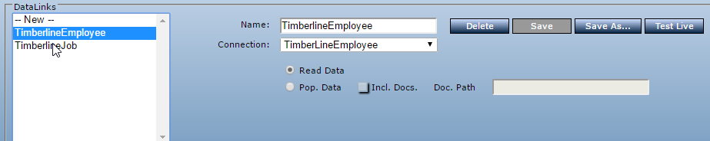

Parameters:
- Input sql query under test value
- Sample @Query
  - SELECT job, description, address_1, address_2, City, State, Zip_Code, Project_Manager FROM master_jcm_job_1 where job=@SelectedValue

